United States North Woods: Animal Tracks

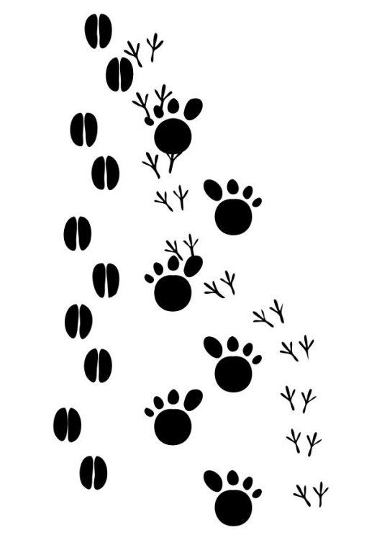
Name:

Track # | Name of Animal
1

2

3

4

5

6

