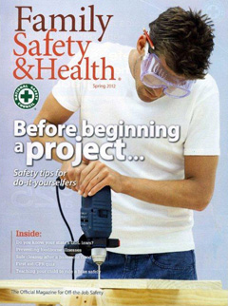
Safety Off-The-Job – Spring 2012

Many injuries, accidents, and near-misses occur because we focus on an outcome rather than on what we are actually doing in the moment. This is true for situations both on and off the job. I mention this fact regularly during training sessions.

Focusing on an outcome is apparent in so many things we do each day. For example, while driving, we sometimes concentrate on getting to our destination quickly rather than observing the speed limit. For home projects, we often assemble everything we need to execute a task, but forget to wear personal protective equipment. When I investigate campus-related injuries and accidents, employees often share with me that safety was not factored into what they were doing in the moment because they were more intent on completing a task.

Perhaps you have taken advantage of the fine weather we have had lately to do things outside. If so, I hope that you have been mindful of incorporating safety into your routine. Actually, I have been really encouraged by behavior I have observed during the past few weeks. Many of my neighbors have used safety eyewear and hearing protection while using power tools.

The spring issue of Family Safety & Health® magazine has much useful information to help you focus on safety “in the moment”. This magazine will be sent to every campus department today. Please take time to read this magazine and share information with your family and friends. I really encourage you to read the cover article on safety tips for do-it-yourselfers.

To receive a personal copy of Family Safety & Health®, please contact the Environmental Health and Safety Office at envirohlth@cortland.edu or at extension 2508. Since there are a limited number of magazines, they will be distributed on a first-come, first-served basis.

For our spring off-the-job safety promotional campaign, we are offering safety eyewear and hearing protection to four employees who request a copy of Family Safety & Health®. Employees will be randomly selected to receive this gift.

Please enjoy the spring and make safety part of your life.

Sincerely,

Glenn W. Wright
Director, Environmental Health and Safety

