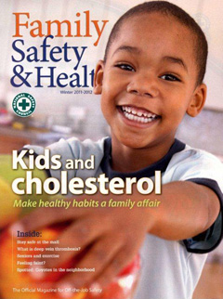
Safety Off-The-Job – Winter 2012

Lately, I have been attuned to practices involving driving and poor visibility from car windshields. Most drivers I observe make an effort to remove snow, ice and fog from their windshields. Some drivers are not so meticulous. A practice that disturbs me to a great extent is one that I call early morning fog fade. Drivers who implement fog fade clear the window just enough to peer through a small area on the lower portion of the windshield. Most of the time, the driver is crouched low in the seat with their head close to the steering wheel. Clearly, this practice does not win a merit badge for safe driving.

I hope you and your family are adequately prepared for winter driving. I recently read an outstanding article on winter driving safety in the latest issue of Family Safety & Health® magazine. This article discusses important items you should have in your travel safety kit, how to safely use jumper cables, and actions you should take if your vehicle becomes stuck or inoperable. Additionally, if you personally practice early morning fog fade, there is useful information in this article to help you.

The winter issue of Family Safety & Health® will be sent to every campus department today. Please take time to read this magazine and share information with your family and friends. To receive a personal copy of Family Safety & Health®, please contact the Environmental Health and Safety Office at envirohlth@cortland.edu or at extension 2508. Since there are a limited number of magazines, they will be distributed on a first-come, first-served basis.

For our winter off-the-job safety promotional campaign, we are offering travel safety kit items to four employees who request a copy of Family Safety & Health®. Employees will be randomly selected to receive this gift.

Please have a safe and enjoyable winter season.

Sincerely,

Glenn W. Wright
Director, Environmental Health and Safety

