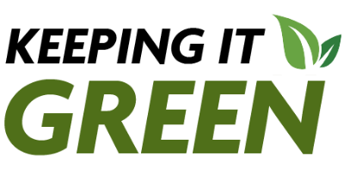
Keeping it Green: March 2026

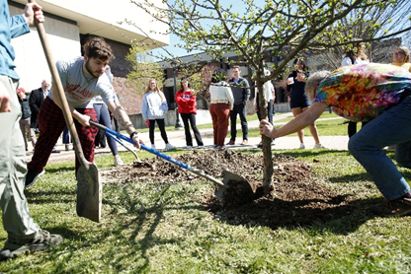
April is Earth Month at SUNY Cortland
SUNY Cortland is getting ready to celebrate Earth Day the entire month of April. Check out the Sustainability Office’s calendar for information full schedule of events celebrates sustainability and environmental conservation. Know of an event that isn’t on our calendar? Email Megan Swing and she will add it.

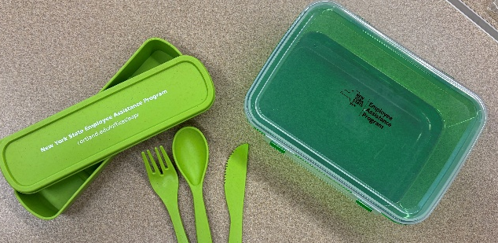
Sustainability Spotlight: EAP creating a culture of reusables
Our March Sustainability Spotlight is The Employee Assistance Program for helping to create a culture on campus moving away from single-use plastics and prioritizing reusables, especially at events!

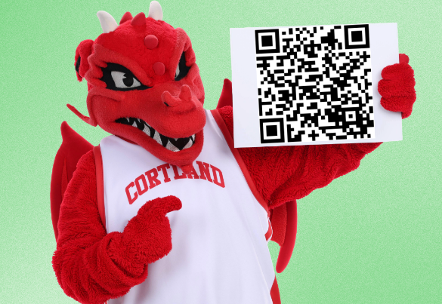
Sustainability Survey
You have an opportunity to help SUNY Cortland strengthen its reputation as one of the “greenest” colleges in the United States by completing the Sustainability Culture Survey. Students who complete the survey by April 18 can enter a random drawing with a chance to win one of six prizes: one of 2 pairs of Spring Fling Tickets or one of 4 CAS gift card’s worth $50 each. You can complete the survey online or scan the QR code.
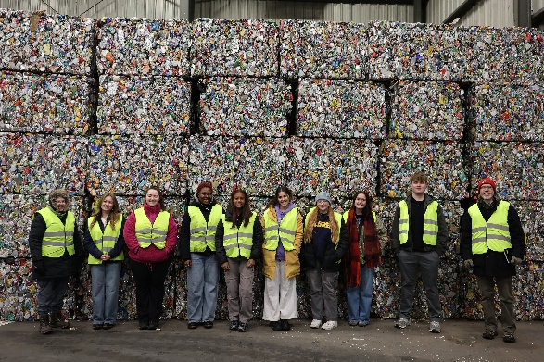
Apply to be a Fall 2026 Green Rep
The Sustainability Office is hiring its cohort of Green Reps for the Fall 2026 semester. To learn more about the position at this link. Students will need to create an account on jobs.cortland.edu to apply.

Check us out on Instagram @cortland.greenreps !

