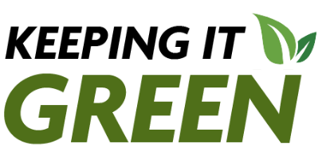
Keeping it Green: February 2026

Sustainability Office Introduces Spring 2026 Green Reps
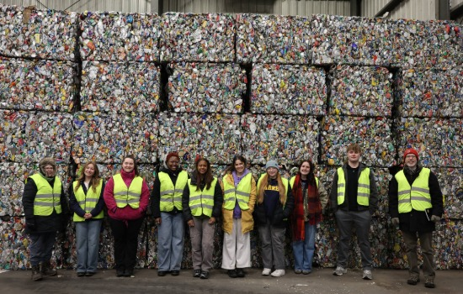
Green Reps will work with their peers on campus this spring to encourage more sustainable lifestyles following visiting examples of sustainable infrastructure in the city of Cortland.

Sustainability Spotlight: Dr. Jiménez as a SUNY Sustainability Faculty Fellow

Our February Sustainability Spotlight is Dr. Jiménez through his work as a SUNY Sustainability Faculty Fellow. In this position, Jiménez is working with other faculty across the SUNY community to incorporate sustainability and other environmental topics into existing courses and lay the groundwork for a community of practice across the SUNY campuses.

Introducing Sustainability Course Attribute
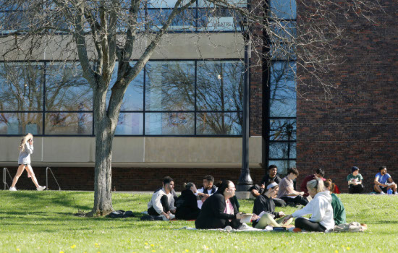
SUNY Cortland's Sustainability Curriculum Committee has created a new course attribute, Sustainability (SUST).


Single-use Plastics, what can be done?
Single-use plastics (SUPs) seem to be everywhere. SUNY Cortland is a piece to the giant puzzle helping to tackle the plastic crisis. It takes everyone to come together to make a change to benefit our campus, our state, and the planet.

Call for events: Earth Month Calendar
The SUNY Cortland Sustainability Office is compiling all the events occurring in April relating to Earth Day and the environment. We want to celebrate the Earth all month long, but to do so we need your help! If you have an event, please share the details in the linked form. We will create a master Earth Month calendar on the SUNY Cortland Sustainability website. We can also help promote events on our social media @cortland.greenreps.

We are also inquiring about interest in doing a Sustainability Fair. If your department, office, or club would like to participate, please reach out to Megan Swing, Energy and Sustainability Engagement Coordinator.

Check us out on Instagram @cortland.greenreps !

