

**Keeping it Green: May 2025**

***Move-Out Edition***

Red Dragon ReUse

**On campus students** can drop off any donations in the donation totes and bins in their Residence Halls from May 5th through May 16th.

**Off-campus students** can drop-off any donations directly to Cortland ReUse (check out their [website](mailto:https://www.reusecortland.org/get-involved) about donation details) or starting May 12th at the donation tote in the Student Life Center Lobby.

When you move out, don’t throw it out! DONATE! 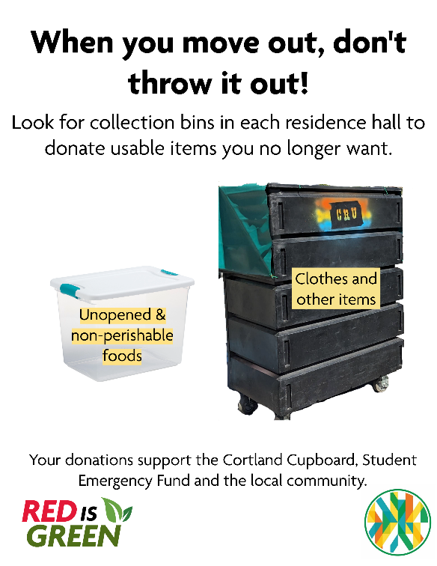

* Unopened & non-perishable food items
* Dishes, silverware, pots & pans
* Printer paper, pens, scissors, and other office supplies
* Sheets, blankets, towels
* Lamps, small furniture, and other household items
* Electronic equipment
* Sports equipment
* Laundry soap, paper products
* Gently worn clothing

Your donations support the Cortland Cupboard, Student Emergency Fund, Cortland ReUse, and the local community!

If any employees would like to volunteer, please fill out this [form](mailto:https://webapp.cortland.edu/Formstack/Services/Forward?form=6150341&viewkey=3cKEGqISEK) by Friday, May 9th.

Grad Gown Donation

To our graduating seniors, congratulations on this huge accomplishment! We encourage the first thing you do as a Cortland alumni is to help support the next class of Red Dragons by donating your gown to the Cortland Cupboard!

Look for donation bins after commencement by the east-facing exit of Park Center and by the tennis courts.

If you aren’t ready to part with their gown right after the ceremony, there is still a way to donate! Alumni can mail their gowns to:

Megan Swing

Facilities Management

SUNY Cortland

P.O. Box 2000

Cortland, NY 13045

How to end the school year and spend your summer sustainably

By Green Rep Ava

**End of the year moving out tips**

* Skip the Bubble Wrap: Wrap fragile items in clothes, towels, or sheets instead of plastic wrap or packing peanuts.
* Donate, Don’t Dump: Don’t toss usable stuff! Donate clothes, furniture, and nonperishable food to Red Dragon ReUse, local shelters, or other donation drives.
* Pack with Purpose--Use bins, laundry baskets, and reusable bags instead of cardboard boxes and plastic wrap.
* Borrow instead of buying!
* Return or Reuse Textbooks: Sell, donate, or swap textbooks instead of letting them gather dust or go to waste.
* Upcycle Broken Items: Turn old t-shirts into cleaning rags or cushion breakables when packing. Reuse damaged posters as packing padding.
* Choose Sustainable Storage: If you’re storing stuff over the summer, look for ecofriendly companies or packs using reused containers.
* Sort E-Waste Properly: Got broken chargers or dead batteries? Don’t toss them, look for electronics recycling bins on or near campus.
* Plan Transportation Wisely: Carpool with friends or combine trips to reduce your carbon footprint

**Summer Sustainability Tips**

* **Pull down shades during daytime hours** to block out hot sun. Open windows at night if the temperature cools down, and capture cross breezes if possible.
* Fast fashion spikes in summer with new swimsuits and festival looks. **Try thrifting or swapping with friends instead**—it’s cheaper, more unique, and way better for the environment.
* **Visit your farmer’s market to buy fresh, in-season fruits and veggies**. This reduces transportation emissions and supports small, sustainable farms.
* Ice cream is synonymous with summer. It tastes delicious and cools you down. What’s more, being eco-friendly is in the palm of your hand. **Order your scoops in a cone to eliminate the waste from single-use cups and spoons.** Bonus points if you order a plant-based / dairy-free ice cream.
* To protect your skin without endangering marine life, **use sunscreen that is reef-safe**. Avoid products containing: oxybenzone, octinoxate, and octocrylene, especially at the ocean. Look for sunscreen with zinc oxide as an active ingredient.
* Spend your summer helping and volunteer! Check-out park or beach clean-ups in your area!
* When organizing summertime excursions, consider **cycling, walking, or public transportation**. To cut down on carbon emissions, **carpool with friends or family** if you’re going to the beach or a local park.
* Water your garden in the early morning or late evening to reduce evaporation. Use a rain barrel to collect water for plants and consider planting drought-resistant or native species.
* Shrink your carbon footprint and help cut air pollution by **using electric grills, mowers, and other landscaping tools**. When tools or appliances need to be replaced, consider electric options.
* Drinking plenty of water and eating water-rich foods like lettuce, cucumbers, melon, and citrus fruits can help you stay well hydrated. **Utilize water-filling stations for reusable bottles** to cut down on single-use plastic bottles and help save money at the grocery store.