Safety Off-The-Job – Summer 2011

Certain behavior at work is often a reflection of what we do off the job. This is particularly true where driving habits are concerned. I have very good news to report regarding the use of seatbelts on campus. During a recent University Police Department survey of 250 vehicles on Neubig Road, 83 percent of drivers or front seat passengers wore their seatbelts. This is a tremendous improvement when compared with the summer 2007 Environmental Health and Safety Office seatbelt survey. During this survey, we determined that approximately 76 percent of campus drivers or front seat passengers wore their seatbelts. I am very pleased with this improvement. You are to be commended!

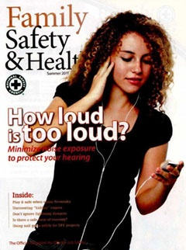
Aside from driving behavior, summer offers many opportunities to reflect on what we do and how we can implement safety in our lives to a greater extent. I read the summer issue of Family Safety & Health® magazine this past weekend. I was quite impressed with the articles that were featured in this issue. Perhaps you are interested in protecting yourself from overexposure to the sun, seeking travel tips, or seeking guidelines on reducing your risks from lightning strikes. If so, you will find much useful information in the summer issue of Family Safety & Health®.

The summer issue of Family Safety & Health® will be sent to every campus department today. Please take time to read this magazine and share information with your family and friends. To receive a personal copy of Family Safety & Health®, please contact the Environmental Health and Safety Office at envirohlth@cortland.edu or at extension 2508. Since there are a limited number of magazines, they will be distributed on a first-come, first-served basis.

For our summer off-the-job safety promotional campaign, we are offering safety eyewear and hearing protection to four employees who request a copy of Family Safety & Health®. Employees will be randomly selected to receive this gift.

Please have a safe and enjoyable summer.

Sincerely,

Glenn W. Wright
Director, Environmental Health and Safety

