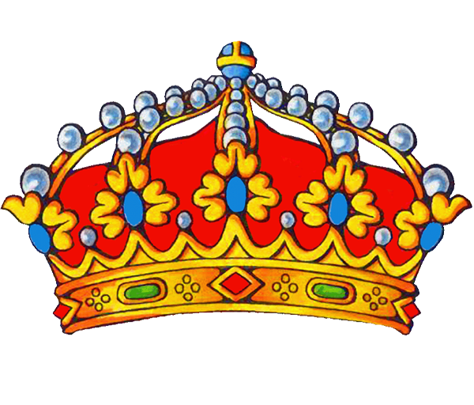
Fall 2015 Homecoming King and Queen Competition Announced!

Want to be crowned SUNY Cortland Homecoming King (or Queen)? If yes, then read on!

The Homecoming King and Queen competition is essentially a fundraiser run by our students.

The Homecoming King competition is currently being coordinated by the Panhellenic Council (Alpha Phi, Alpha Sigma Alpha, Delta Phi Epsilon, and Sigma Delta Tau). All money raised will go to the American Cancer Society.

The Homecoming Queen competition is coordinated by Delta Chi Fraternity. All money raised goes to The V Foundation for Cancer Research.

What does it take to win? Collect the most money!

The Homecoming Court will consist of not only the King and Queen but also the next top 4 money raisers in each competition. The Homecoming Court will be presented during half time at this year’s Homecoming football game on Saturday, September 26, 2015

Homecoming King Specifics:
- Competition is open to any and all male students currently enrolled at SUNY Cortland
- Competition will officially begin on Wednesday, September 9, 2015
- All competitors must be registered with the Panhellenic Council
- Competition will officially close (and all money be turned in) by 12 noon on Friday, September 25, 2015
  - Specifics will be shared with all registered contestants; Money can be dropped off as often as each contestant would like

Homecoming Queen Specifics:
- Competition is open to any and all female students currently enrolled at SUNY Cortland
- Competition will officially begin on Monday, September 7, 2015
- All competitors must be registered with Delta Chi Fraternity
- Competition will officially close (and all money be turned in) by 12 noon on Friday, September 25, 2015
  - Specifics will be shared with all registered contestants; Money can be dropped off as often as each contestant would like

Questions about the Homecoming King competition?
Contact Panhellenic Vice President Allison Akins (Allison.akins@cortland.edu)

Questions about the Homecoming Queen competition?
Contact Delta Chi brother Steve Best (Stephen.best@cortland.edu)

Fall 2015 Homecoming King and/or Queen Registration Sheet

Name:

Phone Number:

Preferred Email Address:

Fall 2015 Living Address:

Year in College:

Group you are representing (if any)?

Completed Homecoming King registration forms can be electronically sent to Allison.akins@cortland.edu OR dropped off with the College’s Greek Advisor (Corey Union, Room 412).

Completed Homecoming Queen registration forms can be electronically sent to Stephen.best@cortland.edu OR dropped off in the Delta Chi mailbox (Corey Union, Room 406).

Thank you for participating!

