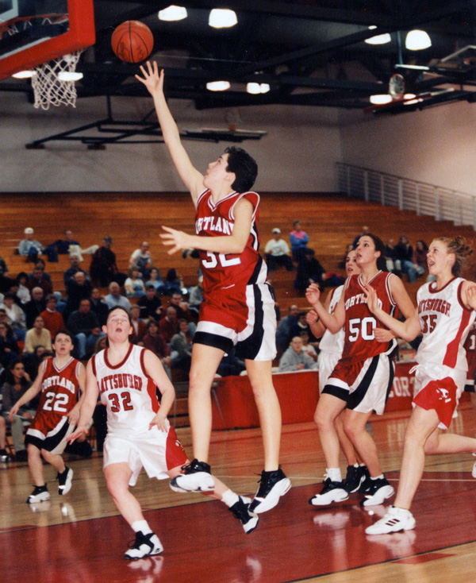

Women’s Basketball
The purpose of a newsletter is to provide specialized information to a targeted audience. Newsletters can be a great way to market your product or service, and also create credibility and build your organization’s identity among peers, members, employees, or vendors.
First, determine the audience of the newsletter. This could be anyone who might benefit from the information it contains, for example, employees or people interested in purchasing a product or requesting your service.
You can compile a mailing list from business reply cards, customer information sheets, Business cards collected at trade shows, or membership lists. You might consider purchasing a mailing list from a company.
If you explore the Project Gallery, you will find many publications that match the style of your newsletter.

Player News

The purpose of a newsletter is to provide specialized information to a targeted audience. Newsletters can be a great way to market your product or service, and also create credibility and build your organization’s identity among peers, members, employees, or vendors.
First, determine the audience of the newsletter. This could be anyone who might benefit from the information it contains, for example, employees or people interested in purchasing a product or requesting your service.
You can compile a mailing list from business reply cards, customer information sheets, Business cards collected at trade shows, or membership lists. You might consider purchasing a mailing list from a company.
If you explore the Project Gallery, you will find many publications that match the style of your newsletter.
Next, establish how much time and money you can spend on your newsletter. These factors will help determine how frequently you publish the newsletter and its length. It’s recommended that you publish your newsletter at least quarterly so that it’s considered a consistent source of information. Your customers or employees will look forward to its arrival.

Newsletter Date

Volume 1, Issue 1
Special Interest Articles
Add a highlight or your point of interest here
Add a highlight or your point of interest here
Add a highlight or your point of interest here

Individual Highlights
Inside Story 2
Inside Story 3
Inside Story 4
Inside Story 5
Inside Story 6
Inside Story 7
Last Story 8

Last Second Shot Beats SUNY Plattsburgh



Page 2
One benefit of using your newsletter as a promotional tool is that you can reuse content from other marketing materials, such as press releases, market studies, and reports.
While your main goal of distributing a newsletter might be to sell your product or service, the key to a successful newsletter is making it useful to your readers.
A great way to add useful content to this newsletter is to develop and write your own articles, or include a calendar of upcoming events or a special offer that promotes a new product.
You can also research articles or find “filler” articles by accessing the World Wide Web. You can write about a variety of topics but try to keep your articles short.
Much of the content you put in your newsletter can also be used for your website. Microsoft offers a simple way to convert your newsletter to a Web publication. So, when you’re finished writing your newsletter, convert it to a website and post it.

Headline

One benefit of using your newsletter as a promotional tool is that you can reuse content from other marketing materials, such as press releases, market studies, and reports.
While your main goal of distributing a newsletter might be to sell your product or service, the key to a successful newsletter is making it useful to your readers.
A great way to add useful content to this newsletter is to develop and write your own articles, or include a calendar of upcoming events or a special offer that promotes a new product.
You can also research articles or find “filler” articles by accessing the World Wide Web. You can write about a variety of topics but try to keep your articles short.
Much of the content you put in your newsletter can also be used for your website. Microsoft offers a simple way to convert your newsletter to a Web publication. So, when you’re finished writing your newsletter, convert it to a website and post it.

Headline

Much of the content you put in your newsletter can also be used for your website. Microsoft offers a simple way to convert your newsletter to a Web publication. So, when you’re finished writing your newsletter, convert it to a website and post it.
You can also research articles or find “filler” articles by accessing the World Wide Web. You can write about a variety of topics but try to keep your articles short.

Headline

“To catch the reader’s attention, place an interesting sentence or quote from the story here.”
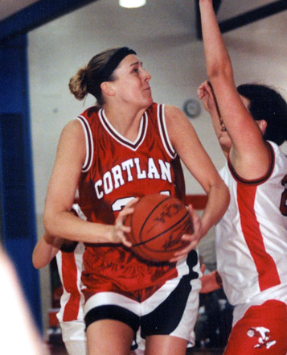Caption describing picture or graphic.
The purpose of a newsletter is to provide specialized information to a targeted audience. Newsletters can be a great way to market your product or service, and also create credibility and build your organization’s identity among peers, members, employees, or vendors.
First, determine the audience of the newsletter. This could be anyone who might benefit from the information it contains, for example, employees or people interested in purchasing a product or requesting your service.
You can compile a mailing list from business reply cards, customer information sheets, Business cards collected at trade shows, or membership lists. You might consider purchasing a mailing list from a company.
If you explore the Project Gallery, you will find many publications that match the style of your newsletter.
Next, establish how much time and money you can spend on your newsletter. These factors will help determine how frequently you publish your newsletter at least quarterly so that it’s considered a consistent source of information. Your customers or employees will look forward to its arrival.
Your headline is an important part of the newsletter and should be considered carefully.
In a few words, it should accurately represent the contents of the story and draw readers into the story.

Headline

Caption describing picture or graphic.
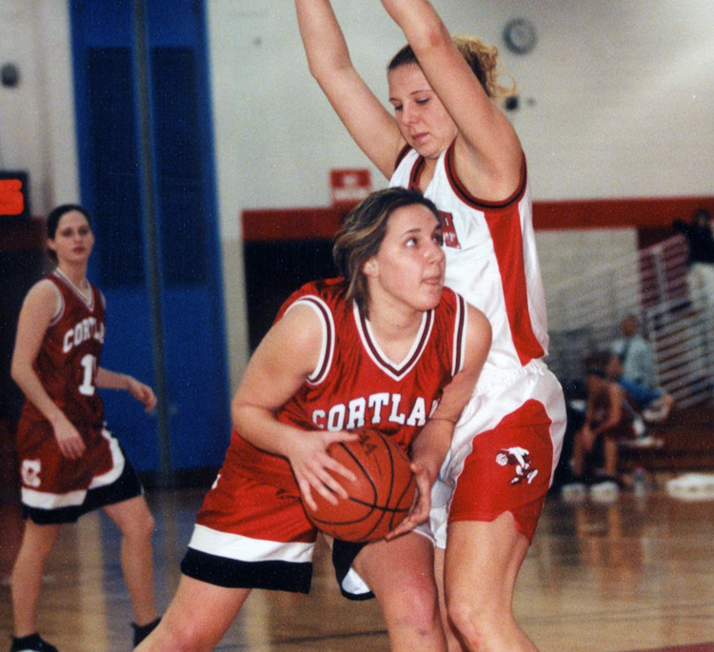

The C-Club General Athletics Fund

By making an investment in SUNY Cortland athletics and/or women’s basketball, you can help build the tradition of excellence that leads us to remarkable achievements. Our teams need your support now more than ever to inspire confidence, encourage perseverance and demonstrate true Red Dragon pride.

Please consider making a contribution to SUNY Cortland athletics or women’s basketball in support of opportunities for our student-athletes. With your generosity, we can face the competition with pride!

To make a gift, visit RedDragonNetwork.org/giving or call the Cortland College Foundation office at 607-753-5744.

Page 3

In a few words, it should accurately represent the contents of the story and draw readers into the story. Develop the headline before you write the story. This way, the headline will help you keep the story focused.
Examples of possible headlines include Product Wins Industry Award, New Product Can Save You Time, Membership Drive Exceeds Goals, and
One benefit of using your newsletter as a promotional tool is that you can reuse content from other marketing materials, such as press releases, market studies.
While your main goal of distributing a newsletter might be to sell your product or service, the key to a successful newsletter is making it useful to your readers.

Continued Story Headline
Women’s Basketball

In a few words, it should accurately represent the contents of the story and draw readers into the story. Develop the headline before you write the story. This way, the headline will help you keep the story focused.
Examples of possible headlines include Product Wins Industry Award, New Product Can Save You Time, Membership Drive Exceeds Goals, and
One benefit of using your newsletter as a promotional tool is that you can reuse content from other marketing materials, such as press releases, market studies.
While your main goal of distributing a newsletter might be to sell your product or service, the key to a successful newsletter is making it useful to your readers.

Continued Story Headline
SUNY Cortland
Athletics Department
Women’s Basketball
P.O. Box 2000
Cortland, NY 13045

Phone
607-753-5788

Fax:
607-753-4929

Email:
yeoman@cortland.edu

We’re on the Web
Visit us at:
www.cortland.edu/athletics
Think about your article and ask yourself if the picture supports or enhances the message you’re trying to convey. Avoid selecting images that appear to be out of context.
Microsoft includes thousands of clip art images from which you can choose and import into your newsletter. There are also several tools you can use to draw shapes

About Our Department
Page 4

