Name: United States North Woods: Animal Tracks

Directions: Using the Track Guide, draw a picture of each animal’s track. Then write 3 to 5 facts about that animal.
Animal | Track | Facts (3 - 5)
Moose |  | - They can grow up to 7ft tall.  - They can weigh more than 1,000 pounds.  - Moose eat woody plants and watery plants like a water lily.
Red Fox

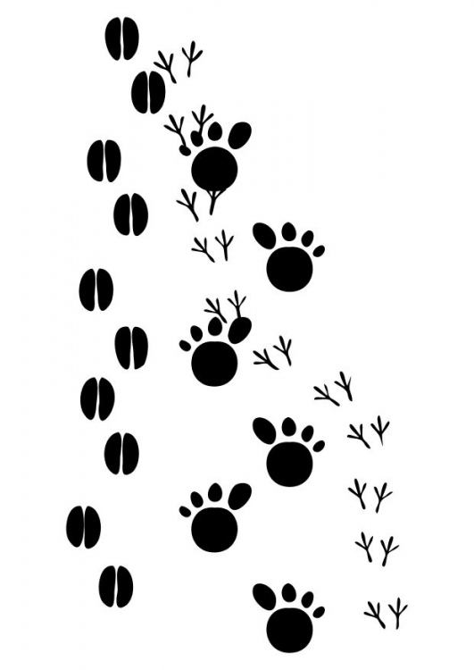
Bobcat
Animal | Track | Facts (3 - 5)
Whitetail Dear

Black Bear

Wild Turkey

