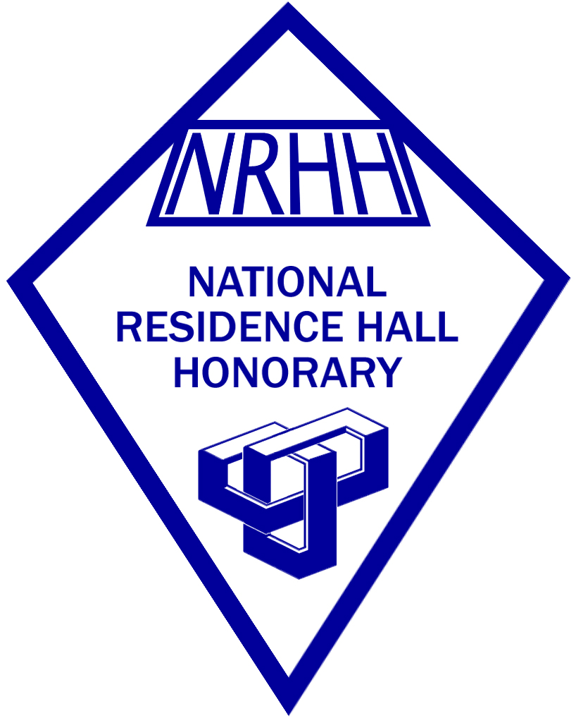**National Residence Hall Honorary**

State University of New York College at Cortland

Rho Delta Chapter

Application for membership Spring 2015

**Dates to remember:**

1. *All application materials (application and two references are to be submitted no later than 4:30 p.m. on November 3, 2014. Late applications will not be accepted.*
2. *The selections and recruitment committee will make their decisions and inform applicants of their status no later than November 17, 2014.*
3. *The induction ceremony will be held on Monday, December 1, 2014 in the Exhibition lounge at 8:30 p.m.*
4. *Meetings are held on Mondays at 9:30 p.m.*

# Section 1: Applicant information

# Name:

# C Number:

Class standing:

Cumulative GPA:

**Section 2: General Questions**

(Please **elaborate** on the following questions).

# List any and all activities you have been a part of on campus. Include Residence Hall activities, campus organizational activities, on campus jobs, honors/awards you have received, and any contributions you have made to the campus community.

1. The four national pillars of NRHH are leadership, recognition, scholastics, and service. Describe how you can contribute to and continue to enhance these pillars.
2. Describe a role model of yours and how they have had an impact on your experiences and decisions.
3. Explain at least one positive and one negative experience you have had in a residence hall community. What do you feel brought on these experiences? How did you go about resolving any negative experiences, if at all?
4. Is there anything else you would like the Selections/Recruitment Committee to know about yourself? (OPTIONAL)

**Section 3: Fundamentals of NRHH**

*The national guidelines for NRHH define five important characteristics a leader possess as being leadership, teamwork, communication, punctuality, and consistency.*

# Out of the five characteristics listed above, which three areas do you consider yourself to be strong in? Which two do you need improvement in and how are you working to improve these weaknesses?

**Section 4: Letters of recommendations**

Please as two people to fill out the recommendation form in your regard. They will need to submit the form through email by the application deadline on November 3, 2014. It is your responsibility to ensure that your recommendation forms are handed in by the prescribed deadline. You can ask any student, staff, or faculty member. Professional recommendations are encouraged but not required. Make sure to provide the person with your C number as that will be a question on the recommendation.

# Section 5: Confirmation of Grades Waiver

I confirm that the information I have provided in this application is true to the best of my knowledge. I also give permission to the NRHH selections and recruitment committee to verify my cumulative GPA at SUNY Cortland in order to authenticate my eligibility as a candidate.

# *By typing my name below, I am providing my electronic signature stating that the above statement is true.*

*Signature:*

*Date:*