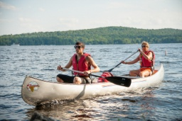
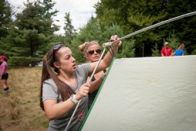
Application for financial assistance

First name Last name
C number:
First Year Student Transfer Student
If you qualify for financial aid for SUNY Cortland, you may be eligible for financial assistance for the ATB experience. Total cost for the ATB experience is $385 and includes room, board and transportation to and from the program site. What amount of assistance are you applying for?

Award requested

$100 $200 $300

If you are approved for financial support at one of these levels, the adjusted balance will be due Aug. 6. We will let you know as soon as a decision is made.

Please tell us in a couple paragraphs why you are interested in joining Adirondack Trail Blazers. Please list any special circumstances we should consider in determining your need for financial assistance. (Feel free to email your responses to outdoor.edinfo@cortland.edu or attach a separate page to this application.)

