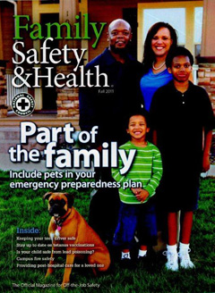
Safety Off-The-Job – Fall 2011

The weekend was absolutely beautiful. I hope you enjoyed it! I devoted Saturday afternoon to completing outdoor projects. Most of this time was dedicated to weeding and cutting my perennial garden. I was so focused on completing this project that I did not observe advice that I often offer to others involving seeking help when lifting heavy items, avoiding awkward postures, and taking regular rest breaks. By Saturday evening, my back was killing me. Sunday was a great day to rest and let my back recover.

On Monday, I reflected on information to highlight for our fall off-the-job safety campaign. I thought about how our health and safety are often related to implementing useful practices we are already familiar with. Although I still find it stimulating to test the limits of my strength, I know that at my age lifting heavy loads is not a good thing, especially where the well-being of my back is concerned. An article in the fall issue of the National Safety Council’s Family Safety & Health® magazine reminded me to be more conscious of observing safe lifting techniques. If I am wise, I will heed the admonition that is offered in the article.

The fall issue of Family Safety & Health® will be sent to every campus department today. Please take time to read this magazine and share information with your family and friends. If you have a pet, I encourage you to read the cover article on including your pet in your emergency preparedness plan.

To receive a personal copy of Family Safety & Health®, please contact the Environmental Health and Safety Office at envirohlth@cortland.edu or at extension 2508. Since there are a limited number of magazines, they will be distributed on a first-come, first-served basis.

For our fall off-the-job safety promotional campaign, we are offering travel flashlights to four employees who request a copy of Family Safety & Health®. Employees will be randomly selected to receive this gift.

Please have a safe and enjoyable fall.

Sincerely,

Glenn W. Wright
Director, Environmental Health and Safety

