Property  - It is your responsibility to clean up your property if there is a mess on it  - Even if the mess was not left by you, the tenants are still held responsible for cleaning it up  Security Deposits  - Make sure to do a thorough job reporting damages of the house  - The landlord cannot keep your security deposit for normal wear and tear such as a dirty carpet  - Make sure to ask for your security deposit before you leave  - Don’t be afraid to ask for your parents help if you are having a hard time getting back your deposit |  |  | Cortland City Government  To report a violation, to look up a code, or any other questions, concerns, or comments, please do not hesitate to contact us. We are here to help.  Contact Us  Deputy Fire Chief and Code Enforcement Officer: William Knickerbocker knick@cortland.org  Zoning Officer: rrhea@cortland.org  City Mayor’s Office: Mayor@cortland.edu  To get more information make sure to view the following links!  http://www.cortland.org/city/fire/code.htm  http://www2.cortland.edu/student-life/off-campus-living/  Major’s Office City Of Cortland: 25 Court Street, Cortland NY 13405  Living Off Campus? Learn Your Rights as A Tenant. |  |  | Living Off Campus? Learn Your Rights as A Tenant.  - Don’t get taken advantage of. As a Tenant know your rights, responsibilities, and the codes that your Landlord must follow.

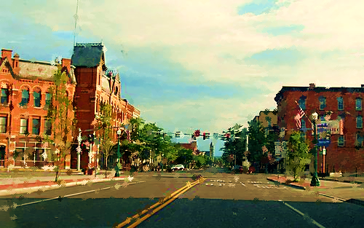  Things College Students Living Off Campus Should Know About  Important Factors about Your Renting Agreements…  There are many options available for SUNY Cortland students who decide to move off-campus. Finding a place to live may be overwhelming for students, as it is usually their first living situation in which a lease is under their own name. Renting for the first time entails new responsibilities for students, but it is also important to know if your landlord follows proper codes and regulations. This brochure will inform you about your rights, responsibilities, codes, and tips to help you along the way. |  |  | Fire and Safety  - Check to make sure the smoke detectors and carbon monoxide detectors work  - Make sure all doors and windows open and close properly  - Housing must be free of environmental hazards, such as but not limited to Lead paint, asbestos  - Don’t be afraid to call for help if you are unsure of these processes  - The minimum size of a bedroom is 70 square feet  - If you live in a legal attic space/3rd floor or above stores/shops make sure there is proper fire protection, such as sprinklers and proper fire escapes  - Make sure to ask for the Rental Permit of the house to check the maximum occupancy of the house  - Heat in the house must be turned on by September 15th  - If there are issues concerns contact the City Code Department headed by Deputy Fire Chief William Knickerbocker.  Quality  - Don’t sacrifice quality for location  - Don’t overcrowd an apartment  - Don’t be afraid to ask parents/guardians for help when looking at houses  - Explore multiple options, don’t just sign on the first apartment you see  - Check out online websites and pictures of other apartment  - Reach out to peers about if they liked their landlord/apartment |  |  | Lease Agreement  - Make sure you have a copy of the original lease you sign, or take pictures of it with your phone  - A clause of the lease that violates federal, state or local city law is a void clause and cannot be enforced  - Example: If in the lease you notice a clause stating the landlord reserves the right to show the house to future renters. This does not mean he can come into your apartment to show it at any time  - ** Your landlord must give you a reasonable amount of time notice before entering your apartment without permission, unless there is an emergency**  - The lease must include information on where to pick up the city’s “Rental Housing Law”  - This can be picked up in City Hall ( 25 Court Street )  - Make sure to ask for the Rental Permit, to check for important things such as maximum occupancy and if the property is registered with the city

